We created a PlayerStats script in the assets/Scripts/Player folder. We replaced monoBehaviour with ScriptableObject, also adding an attribute that allows us to create the object directly from the Unity menu.
Inside the Assets folder, we created a new folder called SO and a ScriptableObject named Player Stats, where we defined the configuration variables, the level, the current health, and maximum health of the player.
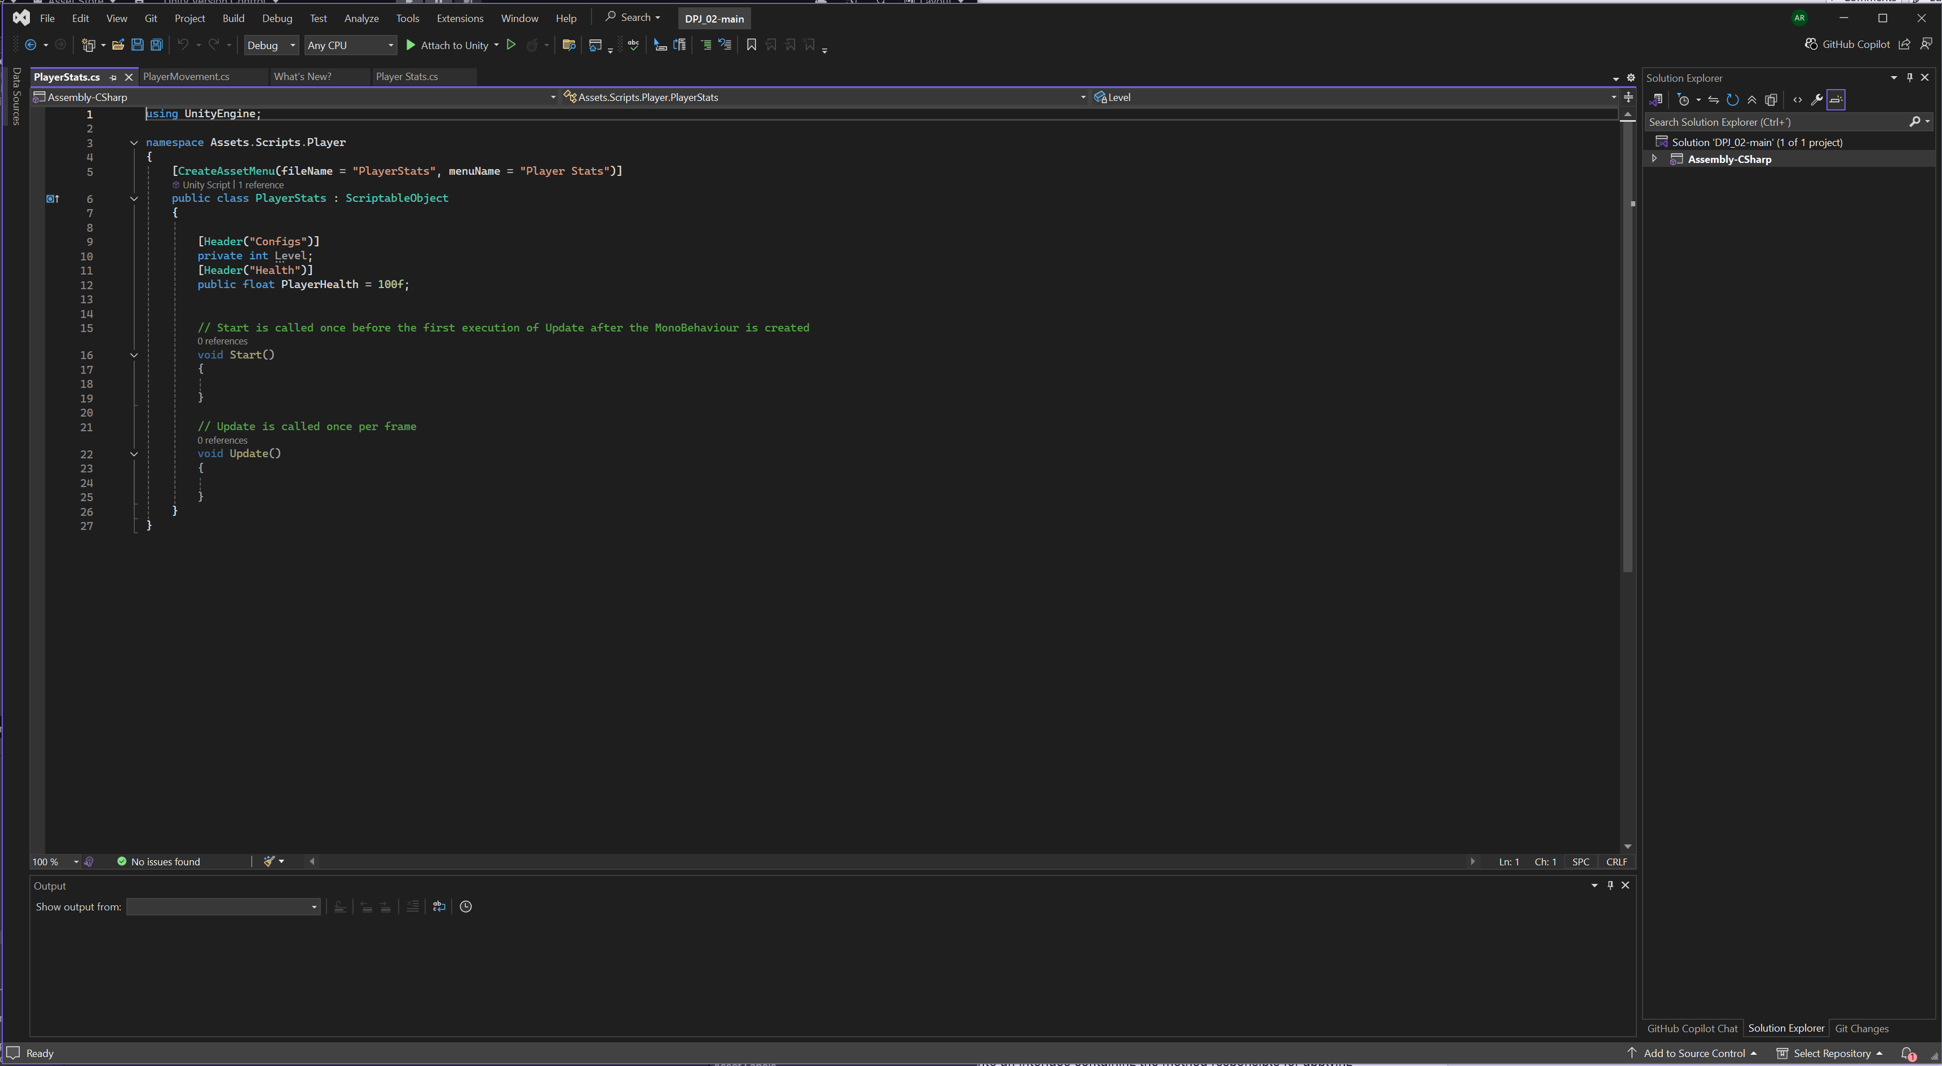

Next, we created the Extra folder and added the IDamageable script , which we turned into an interface containing the method responsible for applying damage. We also created the PlayerHealth script, which implements this interface, allowing us to use the TakeDamage() method.

In the PlayerHealth script, we added a variable of type PlayerStats and made it visible in the inspector. We implemented the TakeDamage() method, which subtracts the player’s health according to the damage received. 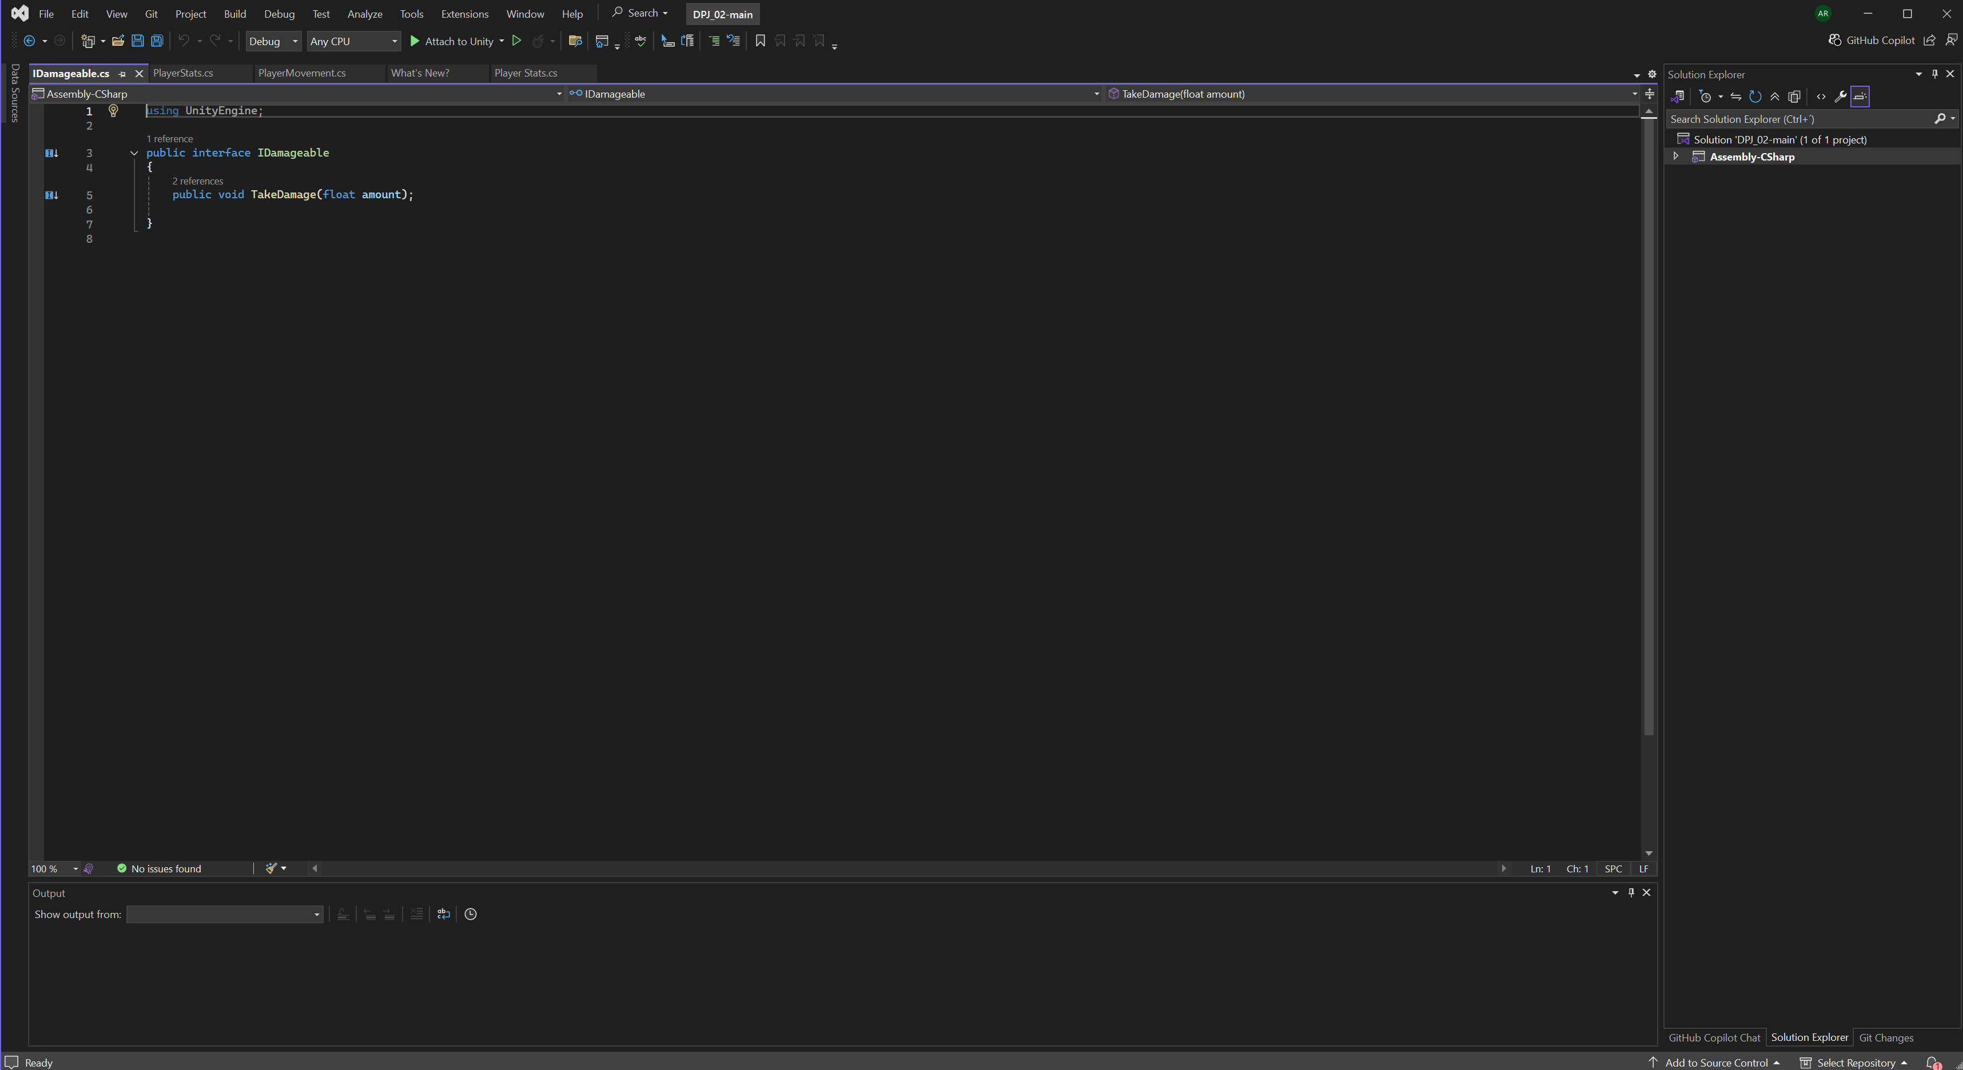
We also created a check that calls the PlayerDead() function when health reaches zero or below, displaying the message "Player Defeated" in the console.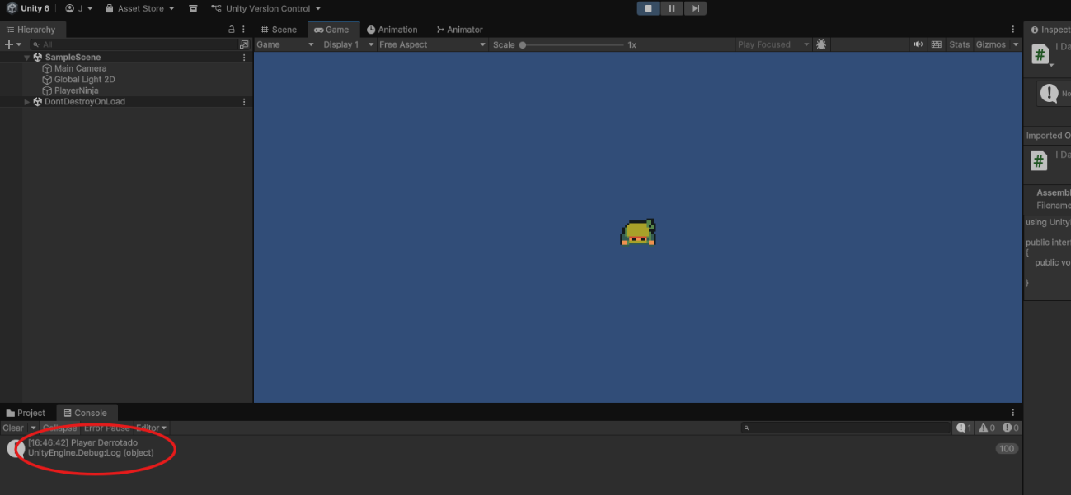

Finally, we added a small test in the Update method that allows simulating damage by pressing the P key, confirming that the system works correctly.
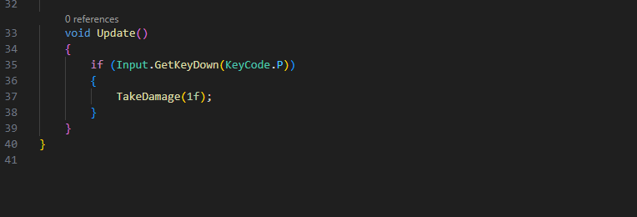

We created an animation called Player_Dead, composed by a single keyframe with the sprite that corresponds to the defeated player. 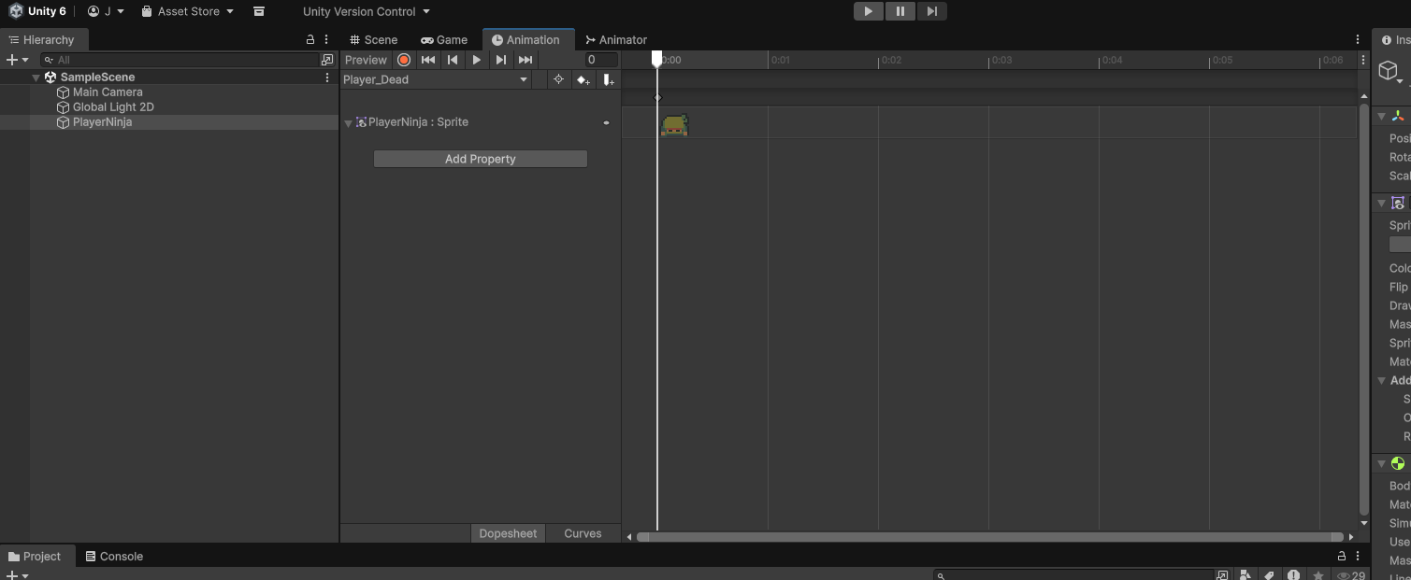
In the Animator, we configured the Dead trigger and a transition from Any State to the death animation, with no exit time or duration.
Then, we created the PlayerAnimations script, responsible for managing the movement and death animations. 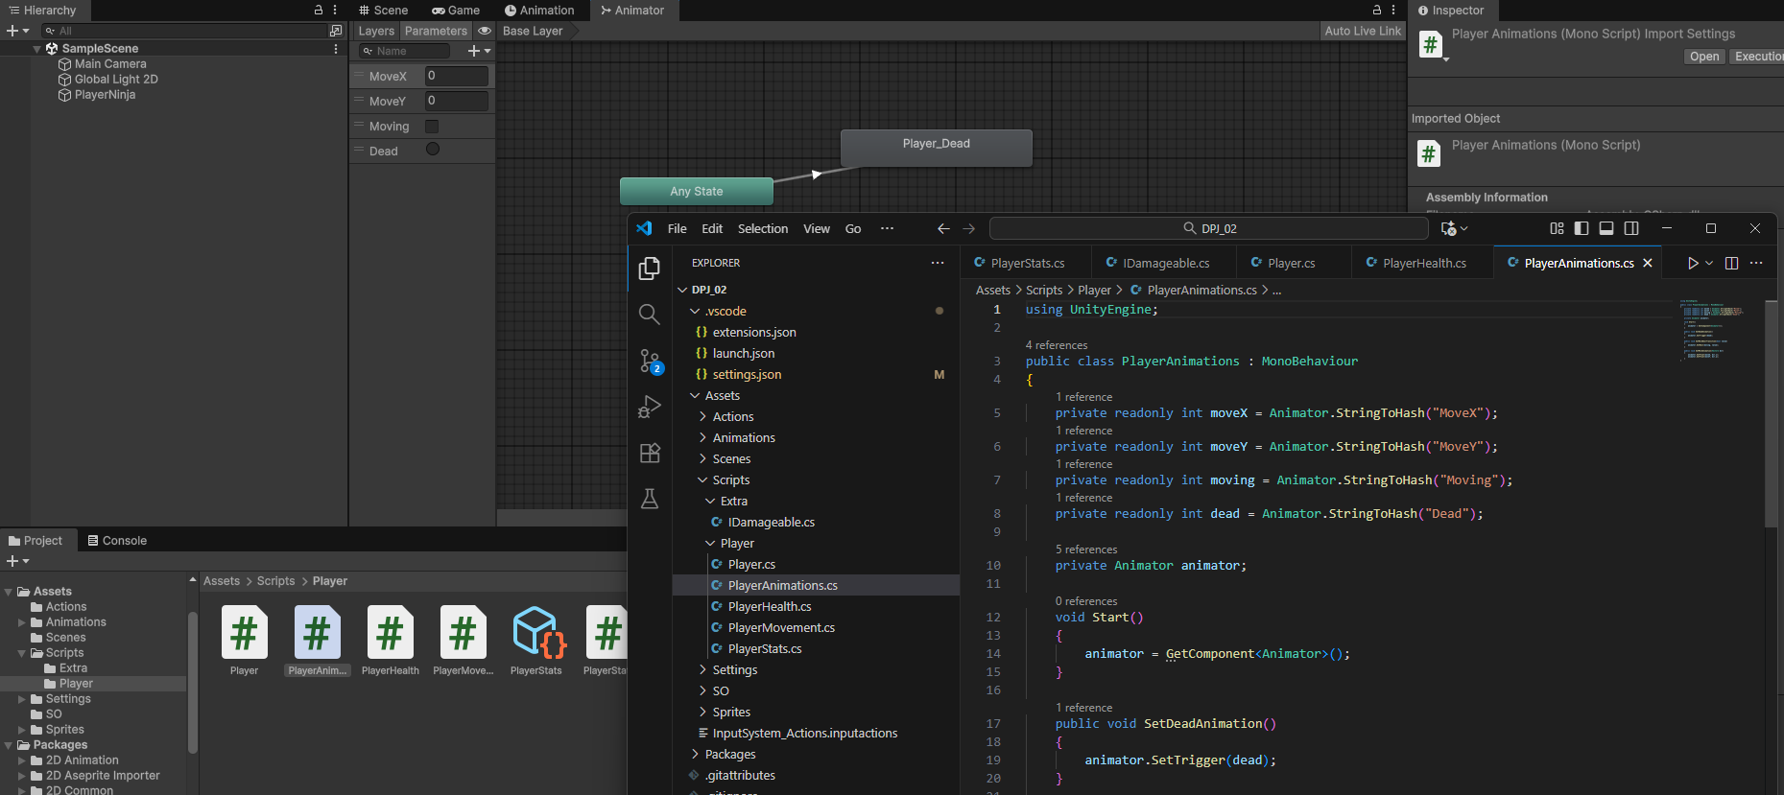

In the PlayerMovement script, we added a PlayerAnimations variable, obtained through GetComponent(). We replaced the old direct references to the Animator with the new functions created in PlayerAnimations. 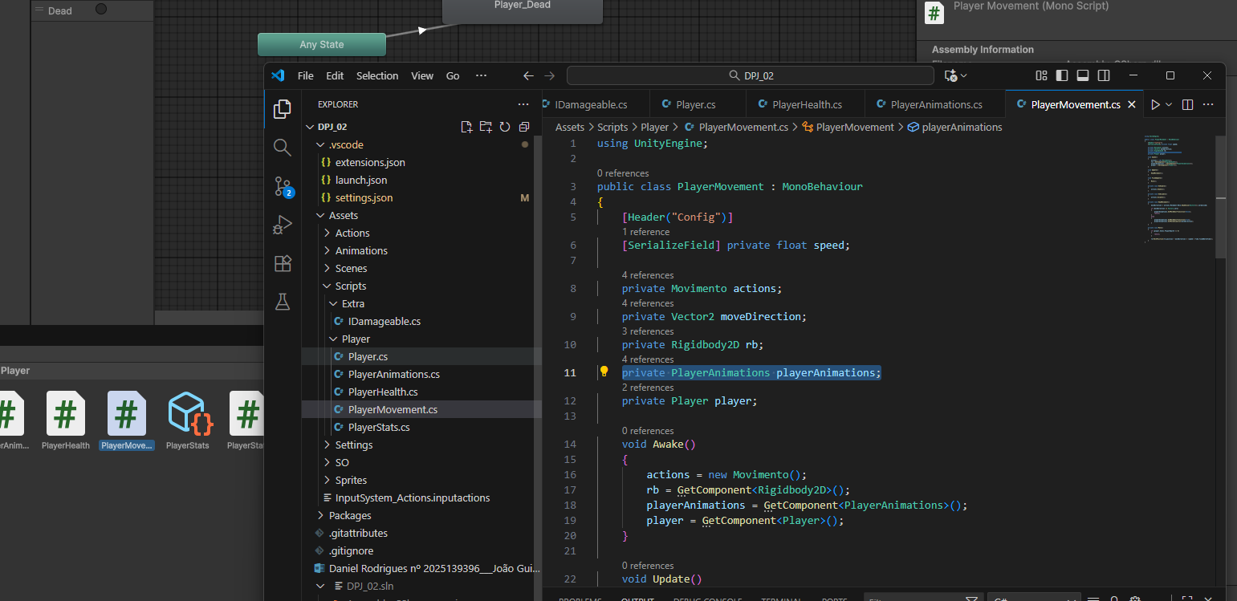
In PlayerHealth, we also added a reference to PlayerAnimations, allowing us to trigger the death animation as soon as the player’s health reaches zero.
We created the Player class, which contains a private PlayerStats variable, visible in the inspector, and a public property that allows access to this data.
In the PlayerMovement script, we added a variable of type Player and checked, within the movement function, whether the health is less than or equal to zero. If so, movement is blocked.
We assigned the Player Stats ScriptableObject to the Player component and tested the final result: the character stops moving when out of health, and the death animation plays correctly. 